# **Multiple Office Users simulation**

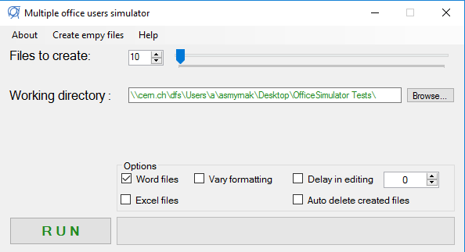

**Arguments:**

*help* : displays the list of available arguments

*nof* + <integer[4-1000]> : number of files to create

*emtfls* : create empty word and/or excel files

*crtfls* : create word and/or excel files with text inside

*usewd* : using word files

*usexl* : using excel files

*vrfrm* : vary formatting in files

*delaysc* + <integer[0-3600]> : delay in seconds during documents creation

*autodel* : auto delete created files (does NOT delete empty files created)

*wrkdir* + <path> : working directory

**Examples:**

• nof 10 emtfls usewd wrkdir "\\cern.ch\dfs\Users\a\asmyrnak\Desktop\OfficeSimulator Tests"  
*(Creates 10 empty word files.)*

• nof 10 crtfls usewd usexl autodel wrkdir "\\cern.ch\dfs\Users\a\asmyrnak\Desktop\OfficeSimulator Tests"  
*(Creates 10 word and 10 excel files. Auto-deletes them at the end.)*

• nof 10 emtfls crtfls usexl vrfrm wrkdir "\\cern.ch\dfs\Users\a\asmyrnak\Desktop\OfficeSimulator Tests"  
*(Creates 10 empty excel files. Creates 10 excel files with various text formatting.)*